**Manual Test Plan for Github App**

For version on 03/10/2019

Vanessa YIN

**Menu**

1. General look with navigation bar
2. Profile page
3. Repository page
4. Follower & following page
5. Different IOS device example
6. General look with navigation bar
   1. Initial screen

(This manual test plan will show examples on iphone7 plus. Too see more examples on different device, see part 5)

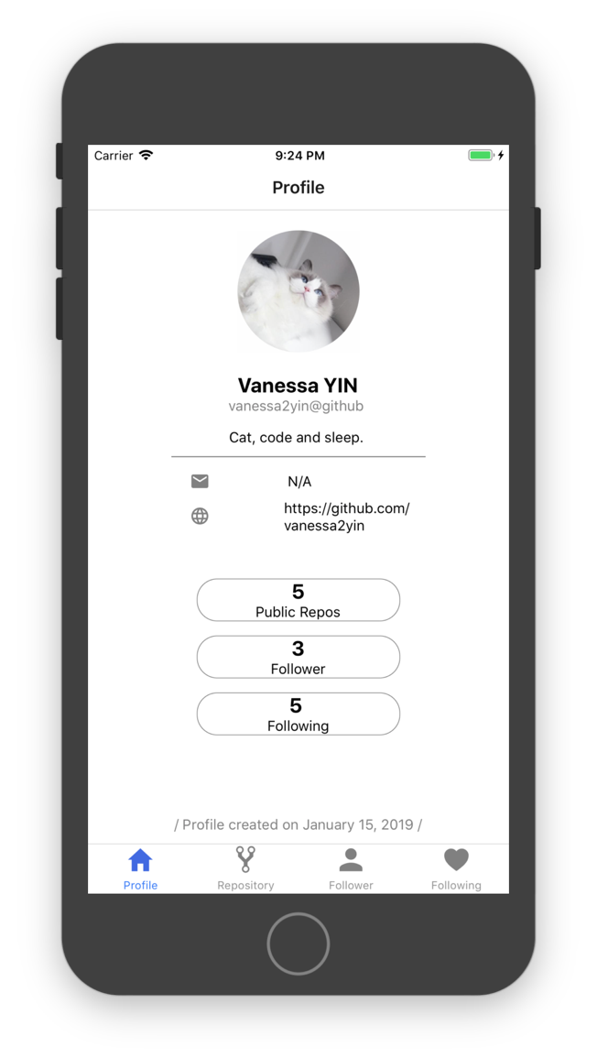

* 1. Tab navigation bar to check if go to correct page

Click on repository, will go to repository page and the tab button of repository will be highlighted. (Should do same test for follower and following.)

After click on repository button:

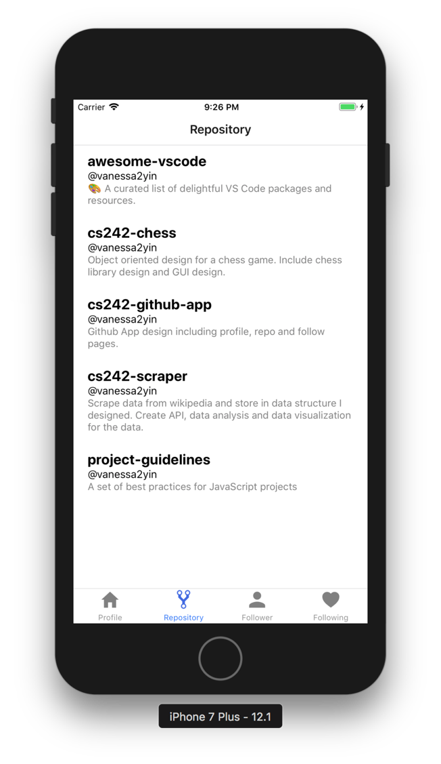

* 1. Check navigation bar is at the bottom of screen when adapt to landscape

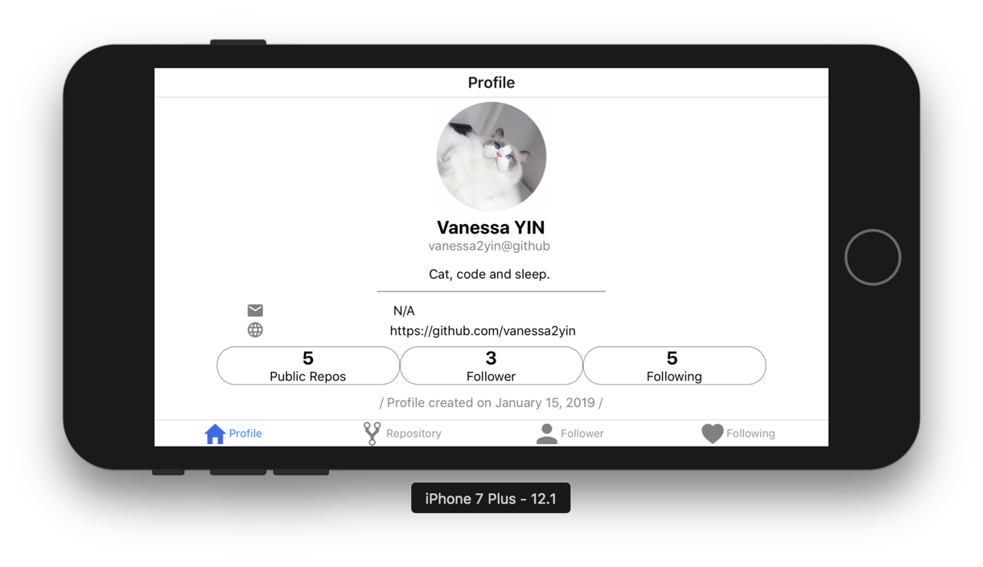

Navigation bar changed its position.

1. Profile page
   1. Check layout for profile. (Screenshot is already included in part1)
   2. Check if page has same info as data fetched from github api.
      1. Postman/web browser result: send GET request to <https://api.github.com/users/vanessa2yin>

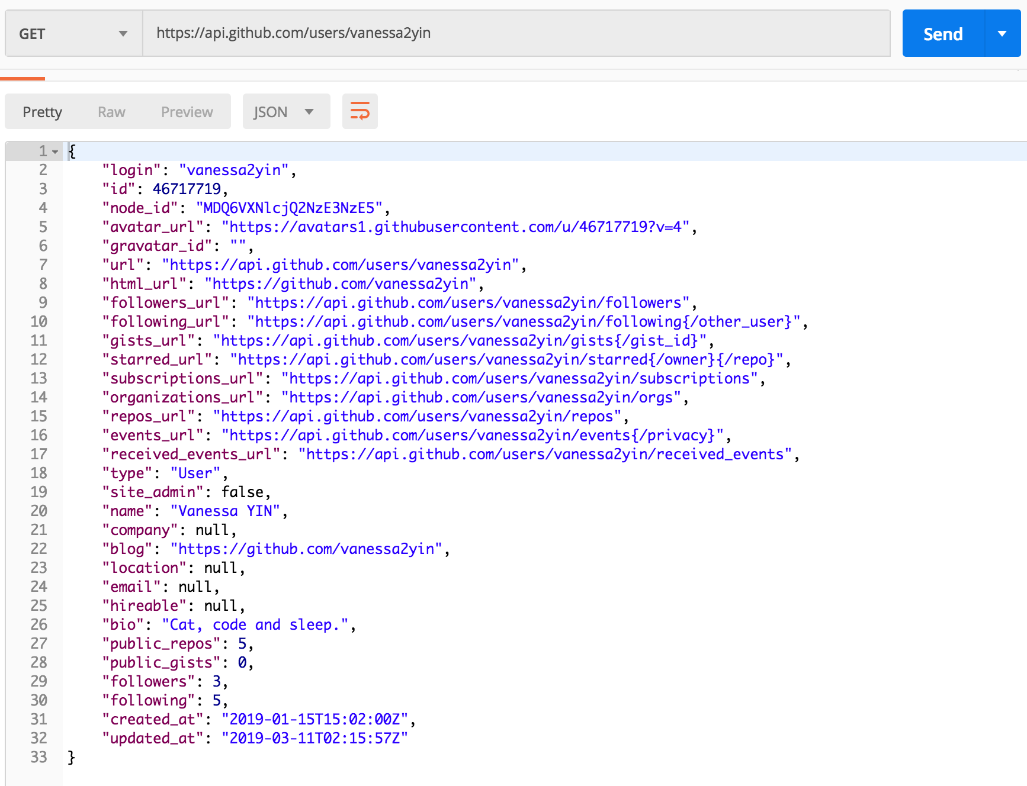

* + 1. App result:

Check if info of avatar, username, bio, email, website, count of public repo/follower/following, create date are correct.

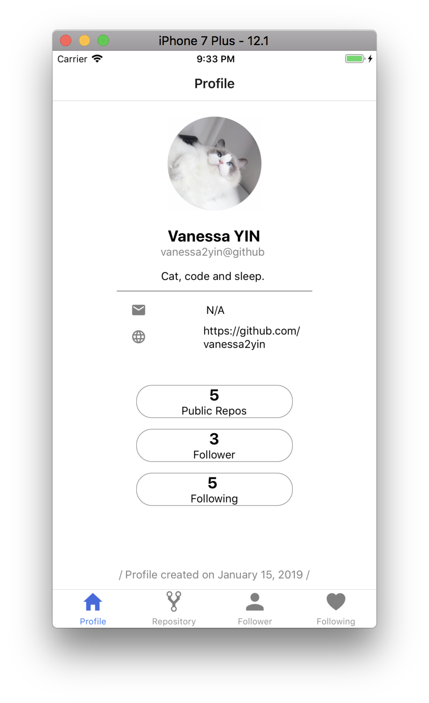

* 1. Check if buttons work
     1. Check if click on [public repos] will go to repository page

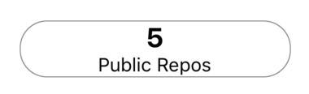

The moment when click on this button, it should change to transparent. 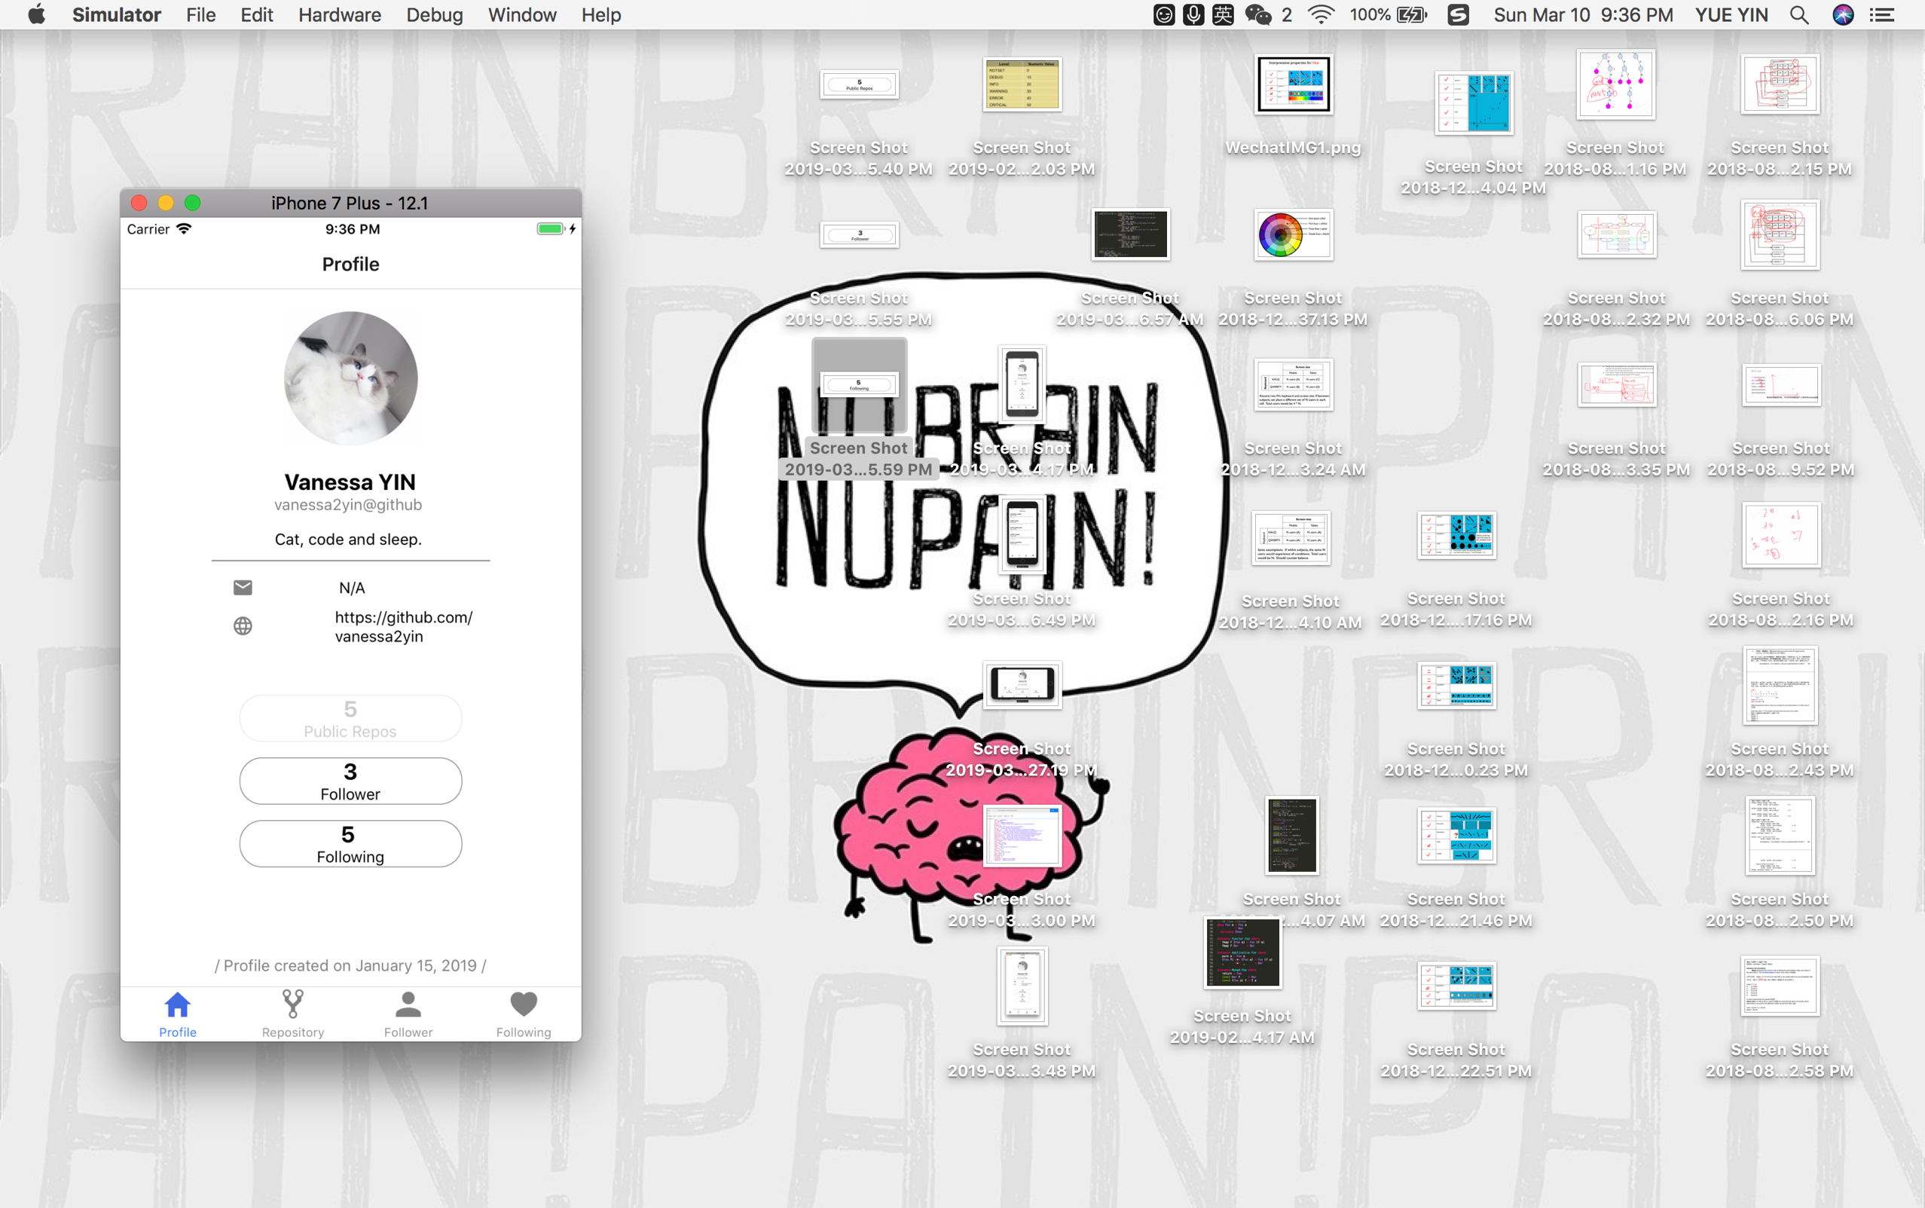

(same for next 2 buttons)

After clicked, it should router to repository page.

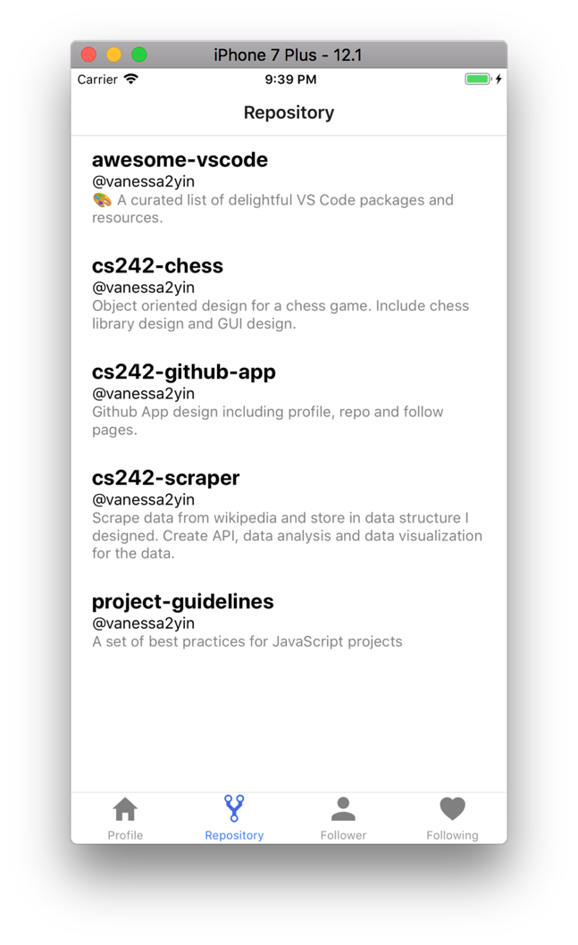

* + 1. Check if click on [follower] will go to follower page

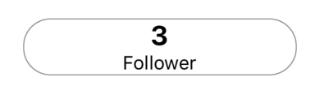

Check the moment when click on it will change to transparent (example see [public repo] button screenshot above)

After clicked, it should router to follower page.

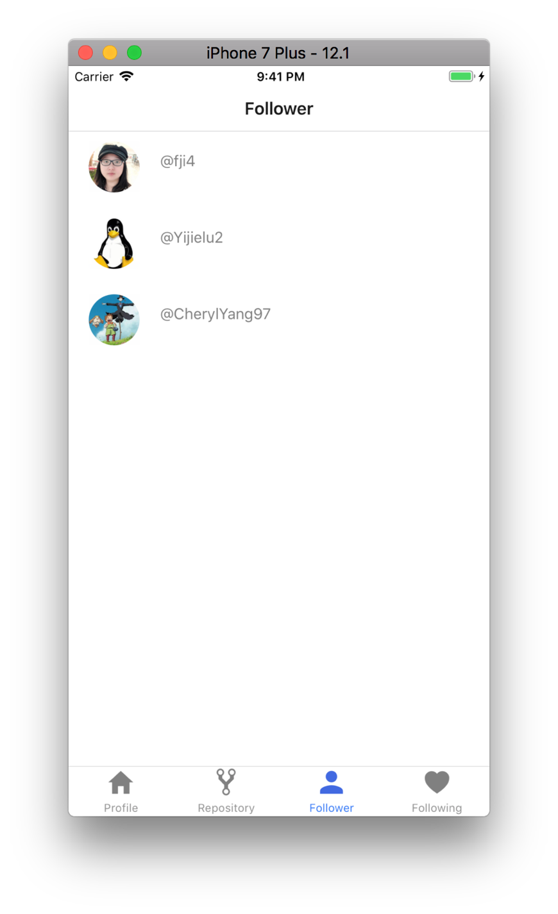

* + 1. Check if click on [following] will go to following page

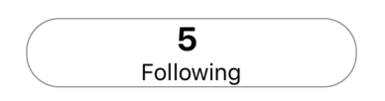

Check the moment when click on it will change to transparent (example see [public repo] button screenshot above)

After clicked, it should router to following page.

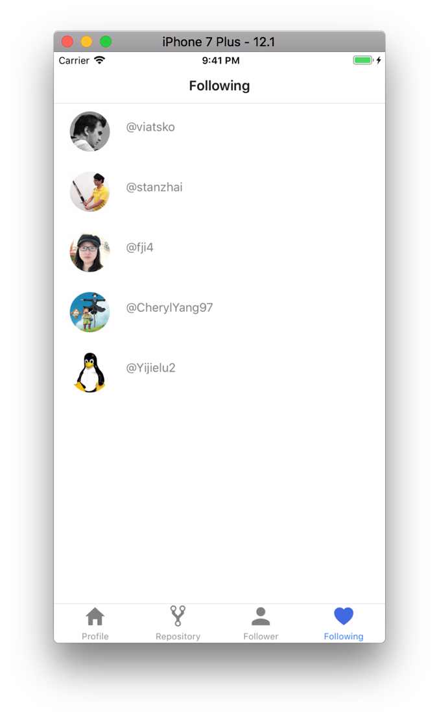

* 1. Check adaptive to landscape

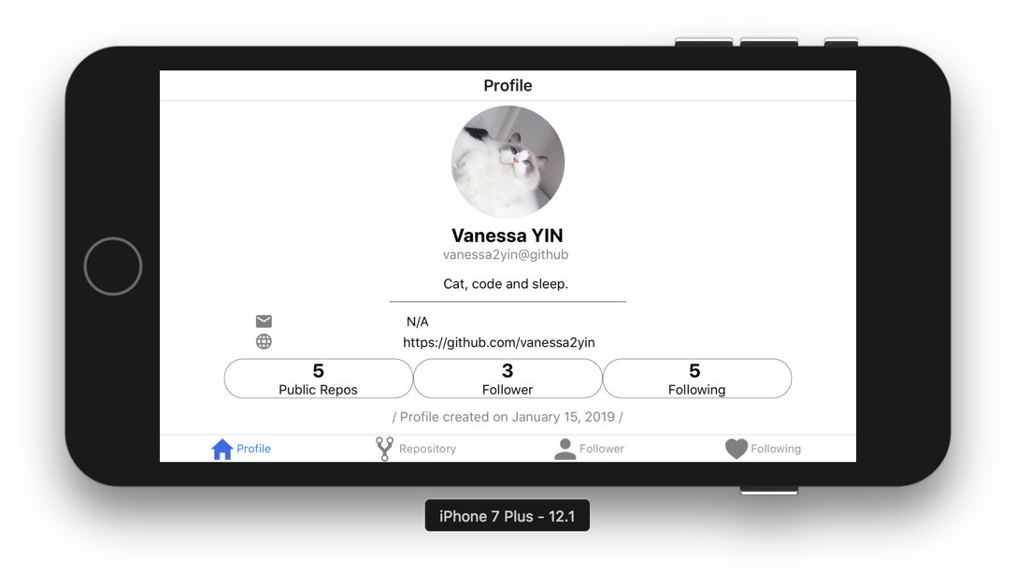

Difference should be: margin on the top of avatar, space between components, and arrangement direction of buttons should be row direction.

1. Repository page
   1. Check layout for profile.
   2. Check if repo has the same info as fetch data from github api
      1. Data from github api: send GET request to <https://api.github.com/users/vanessa2yin/repos>

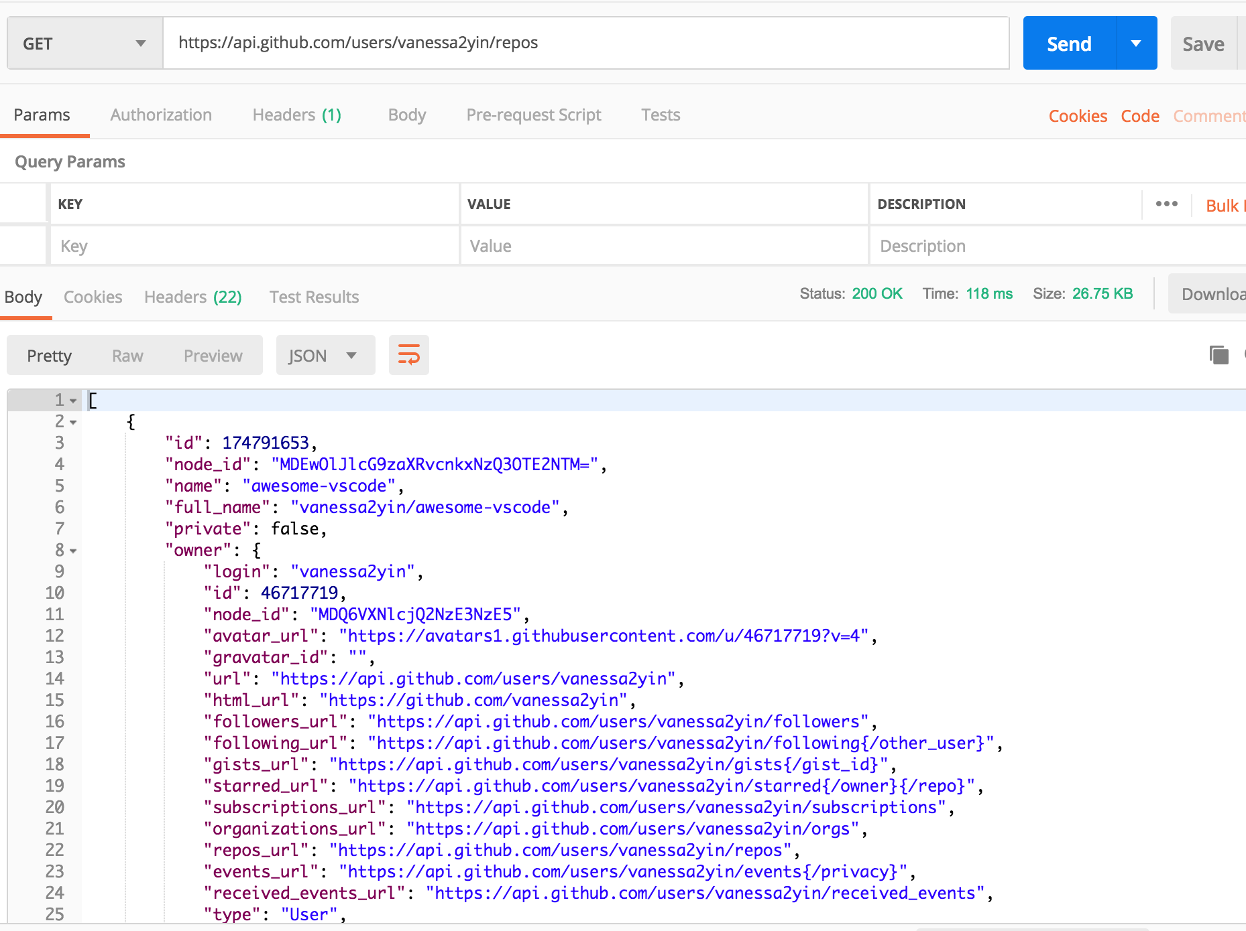

* + 1. Check if the repo name, repo owner and description are correct.
  1. Check if click on list component will open default web browser to the repo GitHub page.

Click on [awesome-vscode] to test:

At the moment when click on it, it should change to transparent.

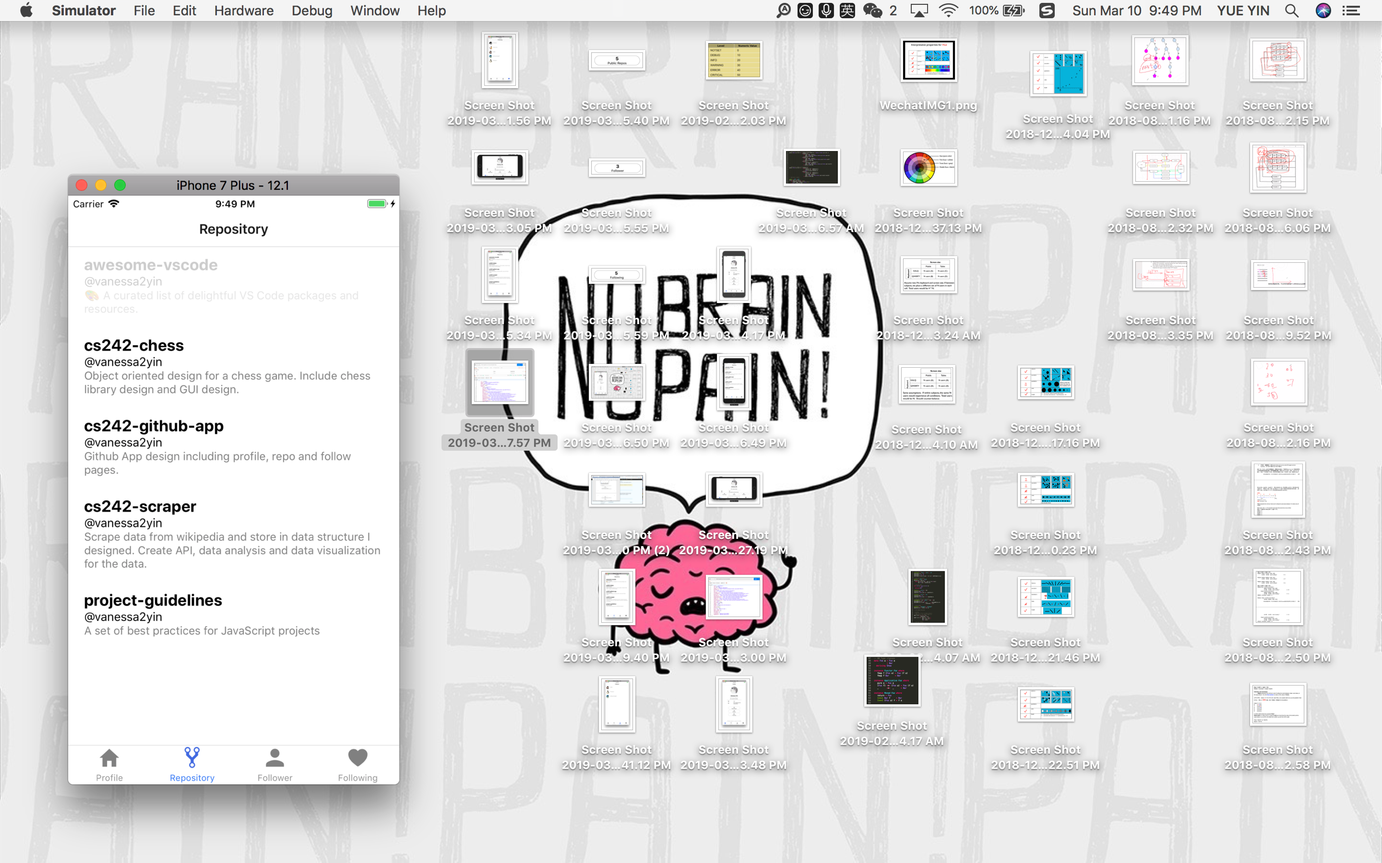

After clicked, it should open the default web browser and router to that git repo.

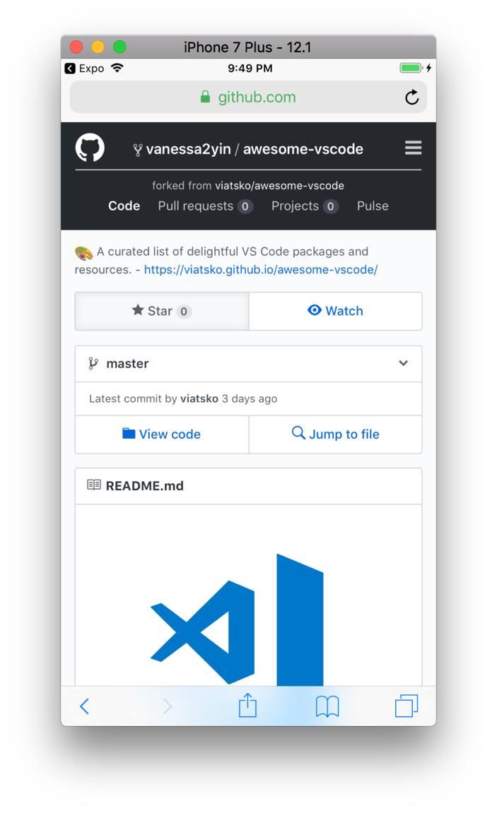

* 1. Check if adaptive to landscape

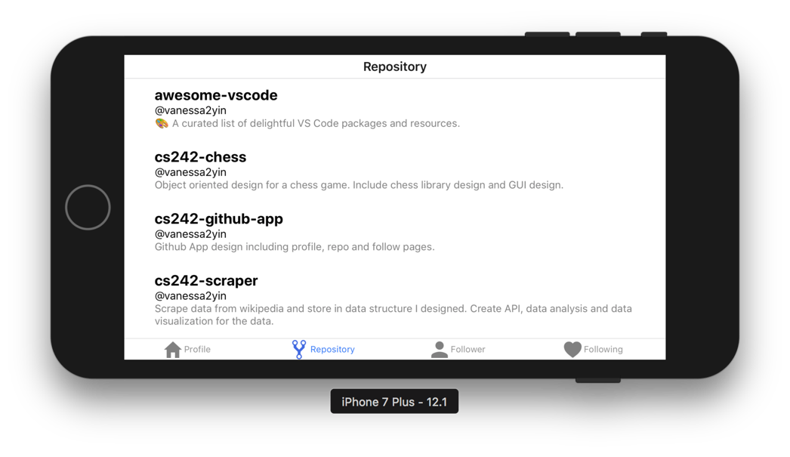

1. Follower & following page
   1. Do this test for both follower and following page.
   2. Initial look for follower and following page

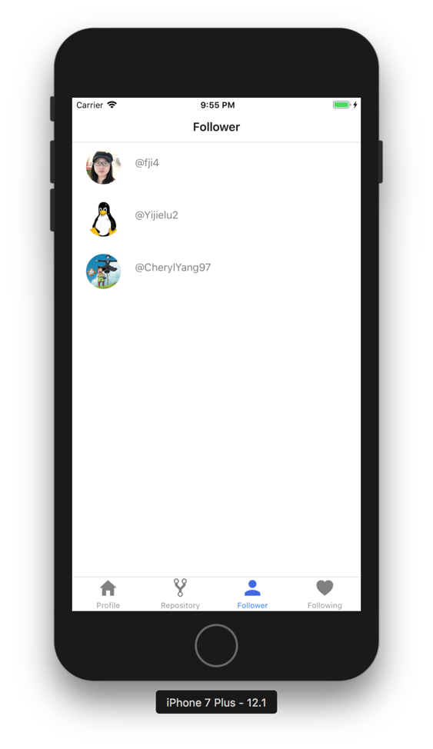 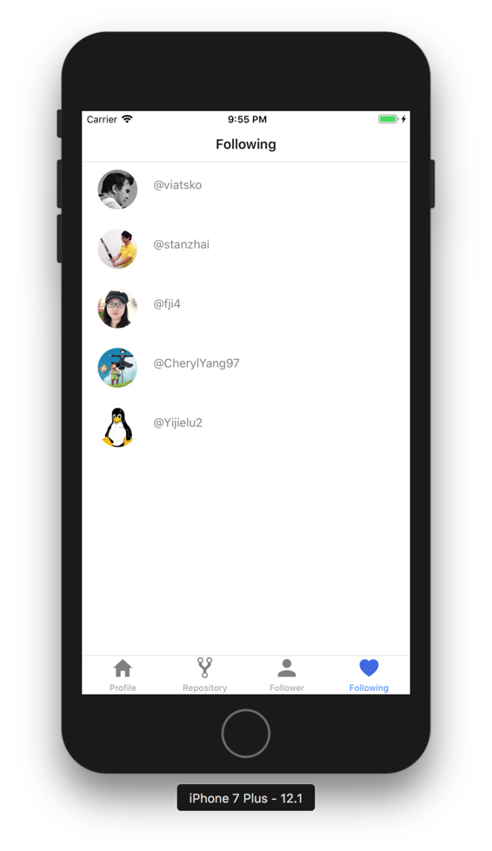

* 1. Click on one component to test if it opens default browser and router to github user page correctly

Take @viatsko on following page as an example:

The moment when clicked on it, it should change to transparent.

After clicked, it should open default browser and router to this github user page.

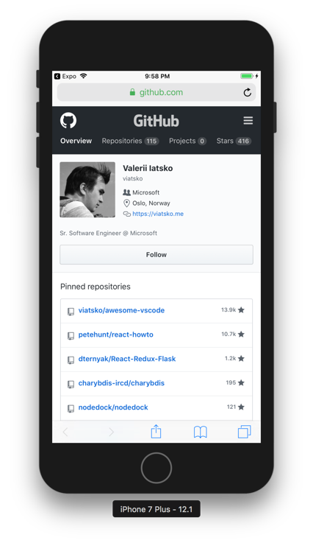

* 1. Check if adaptive to landscape

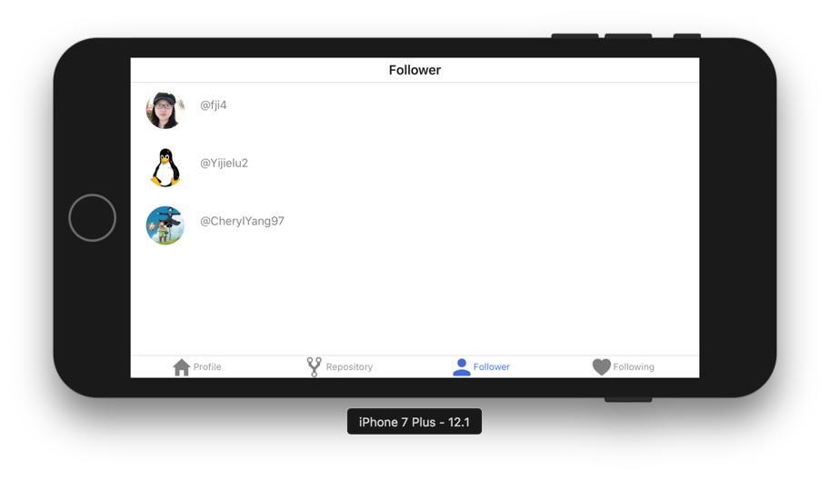

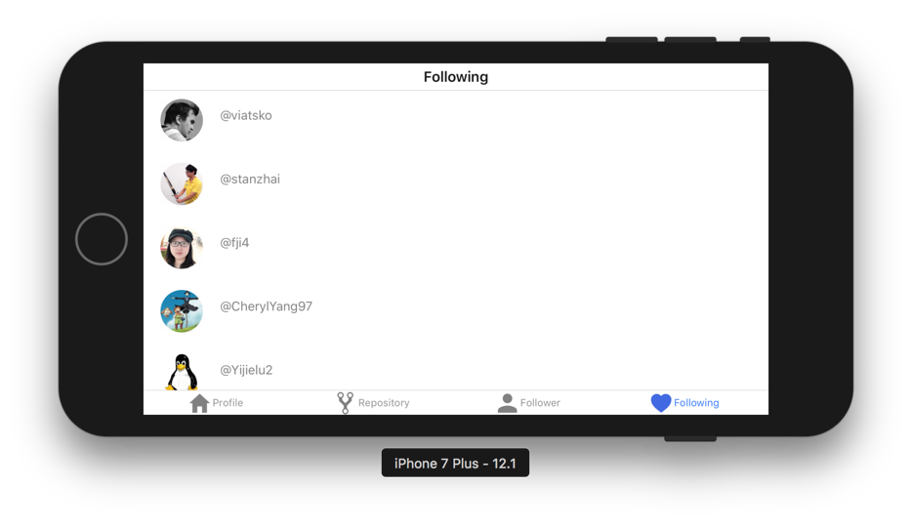

1. Different IOS device example
   1. iPhone 5s

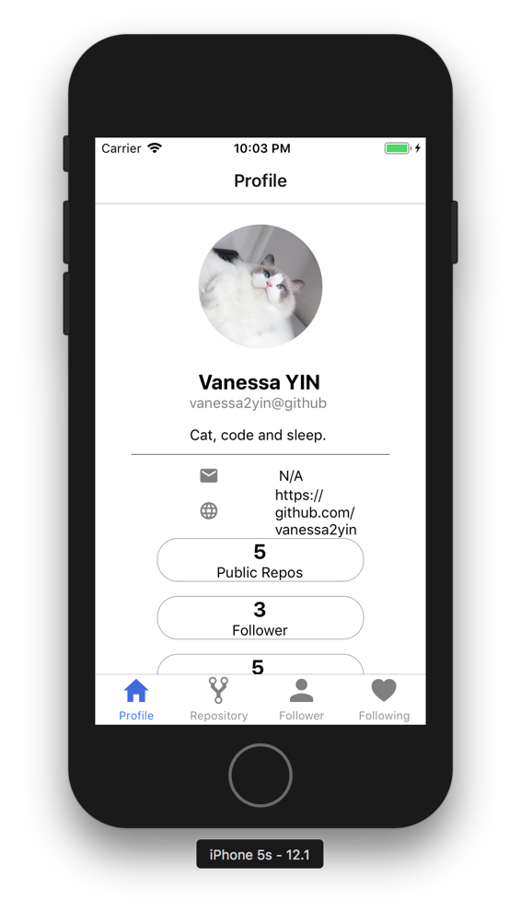 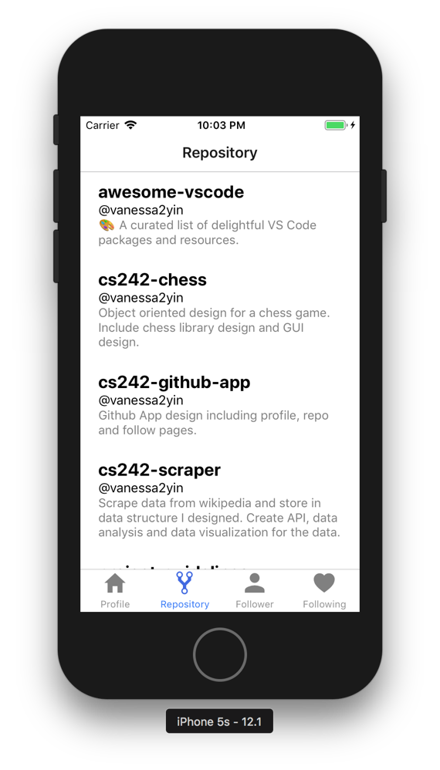

* 1. iPhone XS

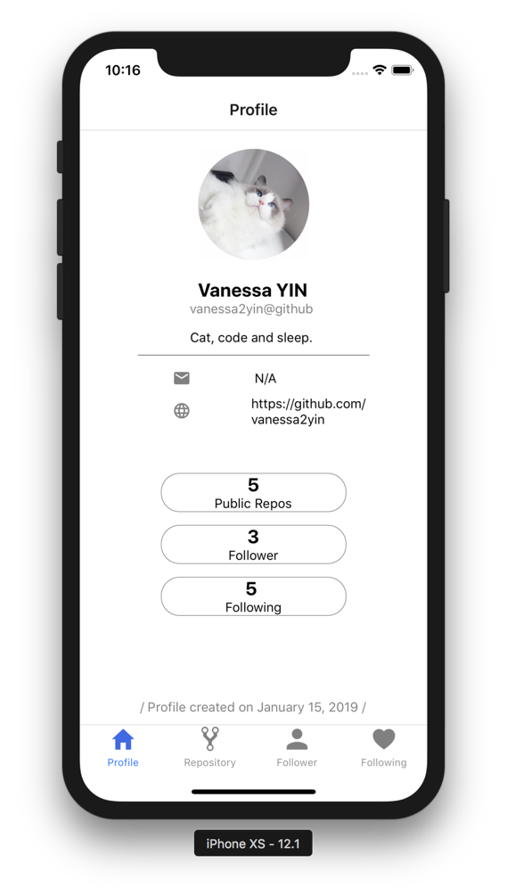 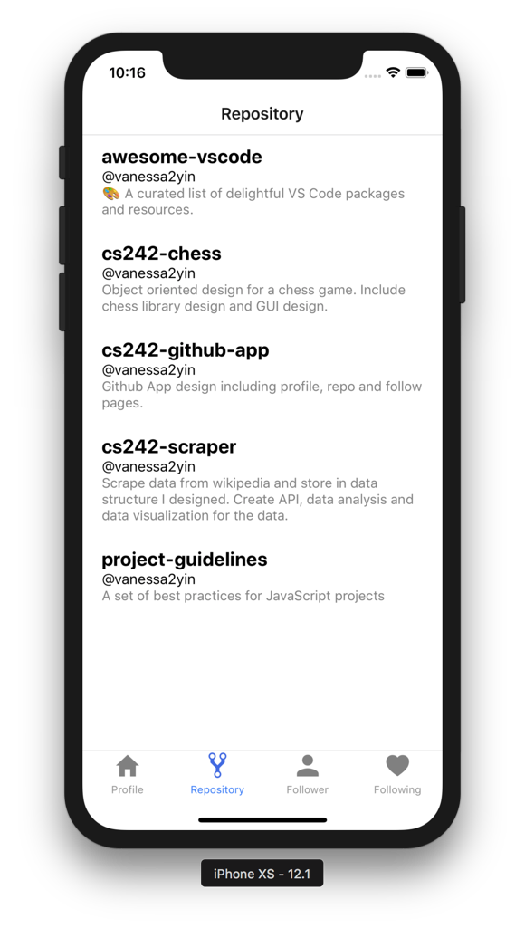

* 1. iPad Air 2

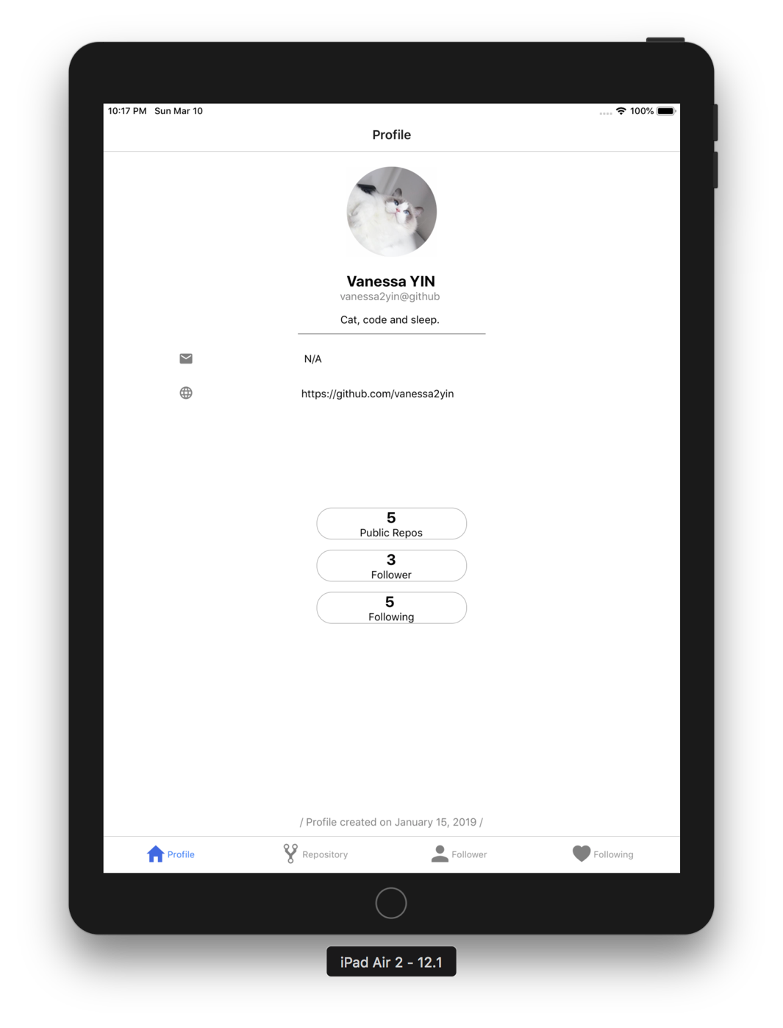

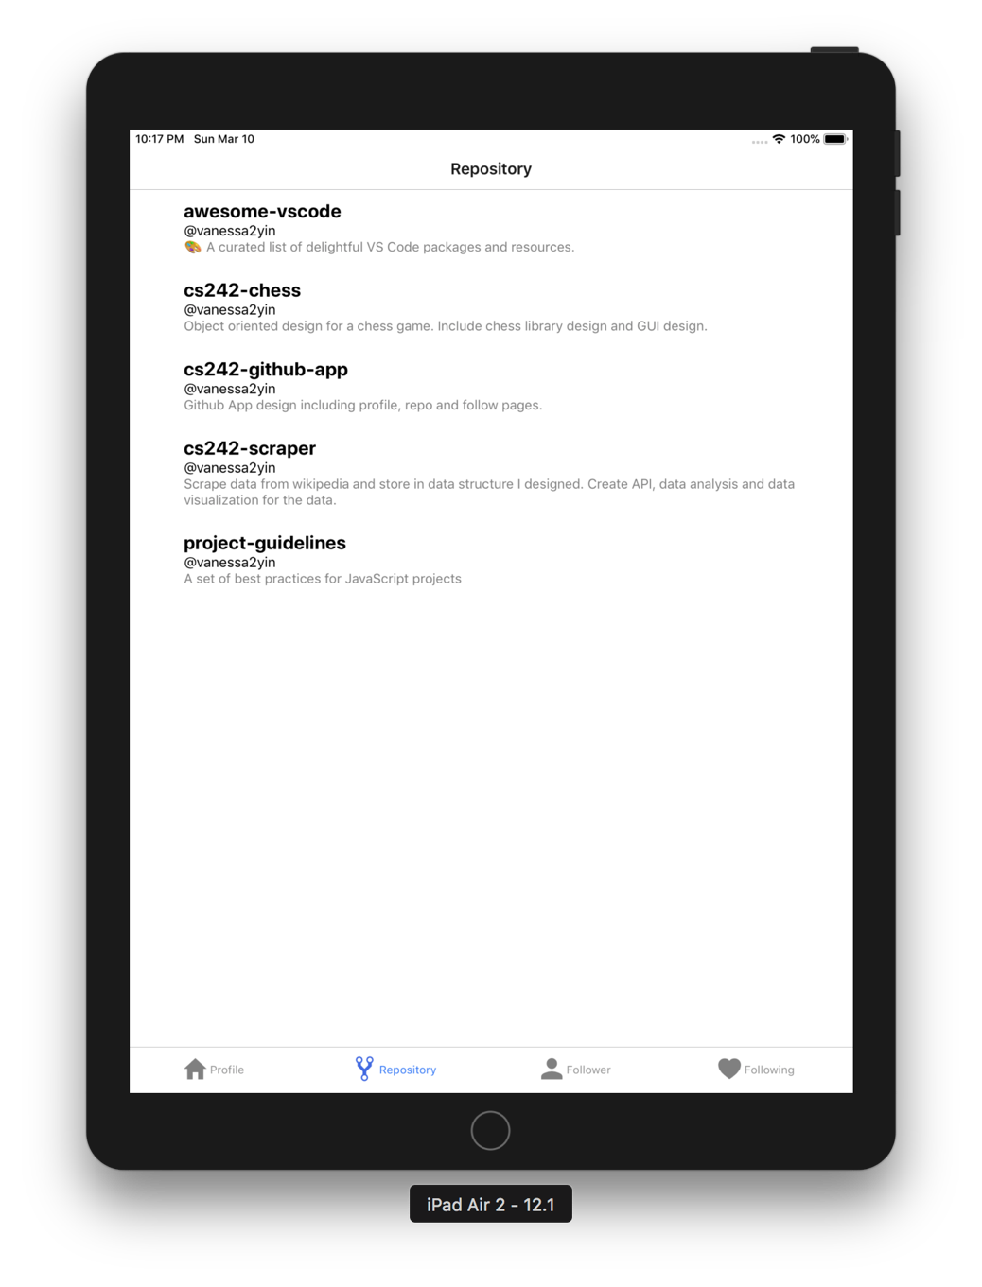

* 1. iPad Pro (10.5inch)

